**Following dataset in an Excel worksheet starting from cell**

A1: Worksheet: SalesData

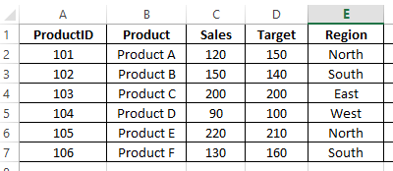

**Q1.Use the IF function to evaluate whether each product met its sales target.**

Ans: **=IF(D2<=C2,"Yes","No")**

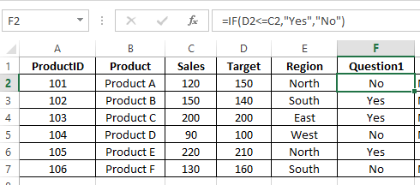

**Q2. Use the IF function to determine if a product is eligible for a regional bonus. Products in the "North" region with sales over 200 are eligible.**

Ans: **=IF(AND(E2="North",C2>200),"Eligible","Not Eligible")**

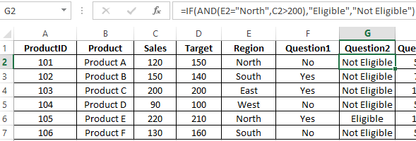

**Q3. Use nested IF functions to assign a commission rate based on sales. Sales >= 200 get a 10% commission, sales >= 150 get a 7% commission, and others get a 5% commission.**

Ans: **=IF(C2>=200,"10%",IF(C2>=150,"7%","5%"))**

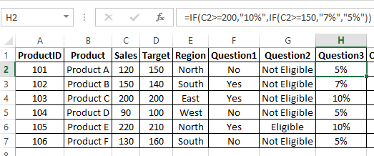

**Q4. Use the IF function to calculate a bonus amount. If sales met or exceeded the target, the bonus is 10% of the sales; otherwise, it's 5%.**

Ans: **=IF(C2>=D2,C2*0.1,C2*0.05)**

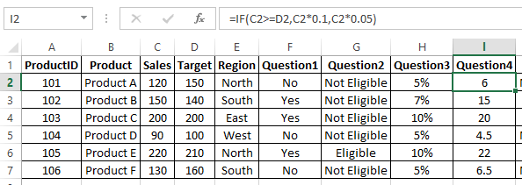

**Q5. Use the IF function to categorize sales performance as "Excellent" (>=200), "Good" (>=150), or "Needs Improvement" (<150).**

Ans: **=IF(C2>=200,"Excellent",IF(C2>=150,"Good","Needs Improvement"))**

